**1. What does RGBA stand for?**

**Answer:-** RGBA stands for Red-Green-Blue-Alpha

**2. From the Pillow module, how do you get the RGBA value of any images?**

**Answer:-** The RGBA value is a tuple of 4 integers, each ranging from 0 to 255 . So, to calculate that value of any image first we have to import image from PIL and then we have to calculate RGBA value of each colour of that image, by importing Imagecolor module from PIL and calling a function ImageColor.getcolor(‘name of color’, ‘RGBA’)

**3. What is a box tuple, and how does it work?**

**Answer:-** Box tuple: It is a tuple value of four integers: **Leftmost edge** x-coordinate, **Top edge**

y-coordinate, **Right** the width, **Bottom** the height **r**espectively.

These four integer coordinates represent a rectangular region in an image .

Like in cropping it is being used and created new image with the given coordinates.

Box tuple includes Left coordinate which starts at zero and increases going from left to right and the Top coordinate which starts at zero and increases going down the image and it does not include right and bottom coordinates while representing.

Example: Box tuple (3,1,9,6)

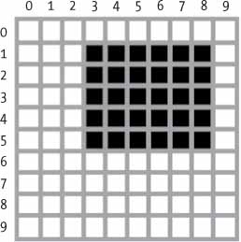

**4. Use your image and load in notebook then, How can you find out the width and height of an Image object?**

**Answer:-** by using

**5. What method would you call to get Image object for a 100×100 image, excluding the lower-left quarter of it?**

**Answer:-**

**6. After making changes to an Image object, how could you save it as an image file?**

**Answer:-**

**7. What module contains Pillow’s shape-drawing code?**

**Answer:-**

**8. Image objects do not have drawing methods. What kind of object does? How do you get this kind of object?**

**Answer:-**